**Chapter 6**

**Power Series**

**6.4 Working with Taylor Series**

**Section Exercises**

**In the following exercises, use appropriate substitutions to write down the Maclaurin series for the given binomial.**

175. 

Answer: 

177. 

Answer: 

**In the following exercises, use the substitution in the binomial expansion to find the Taylor series of each function with the given center.**

179. at

Answer: ;

181. at (*Hint:*)

Answer: so

183. at

Answer: so

185. at

Answer: 

**In the following exercises, use the binomial theorem to estimate each number, computing enough terms to obtain an estimate accurate to an error of at most.**

187. **[T]**using 

Answer: . Using, for example, a fourth-degree estimate atgiveswhereas . Two terms would suffice for three-digit accuracy.

**In the following exercises, use the binomial approximation forto approximate each number. Compare this value to the value given by a scientific calculator.**

189. **[T]** usingin

Answer: The approximation is; the CAS value is 

191. **[T]**using in

Answer: The approximation is; the CAS value is 

193. **[T]** Recall that the graph ofis an upper semicircle of radius . Integrate the binomial approximation ofup to order  fromtoto estimate

Answer: . Thus

whereas 

**In the following exercises, use the expansion to write the first five terms (not necessarily a quartic polynomial) of each expression.**

195. 

Answer: 

197. 

Answer: 

199. Use the approximation forto approximate.

Answer: Twice the approximation is whereas.

201. Find the th derivative of

Answer: 

**In the following exercises, find the Maclaurin series of each function.**

203. 

Answer: 

205.  ,

Answer: For,.

207. 

Answer: 

209. using the identity

Answer: 

**In the following exercises, find the Maclaurin series of  by integrating the Maclaurin series of term by term. If is not strictly defined at zero, you may substitute the value of the Maclaurin series at zero.**

211. 

Answer: 

213. 

Answer: 

215. 

Answer: 

217. 

Answer: 

**In the following exercises, compute at least the first three nonzero terms (not necessarily a quadratic polynomial) of the Maclaurin series of.**

219. 

Answer: 

221. 

Answer: 

223. 

Answer: 

225.  (see expansion for)

Answer: Using the expansion for gives

**In the following exercises, find the radius of convergence of the Maclaurin series of each function.**

227. 

Answer:  so by the ratio test.

229. 

Answer: so  by the ratio test.

231. Find the Maclaurin series of

Answer: Add series of and term by term. Odd terms cancel and 

233. **[T]** Letand denote the respective Maclaurin polynomials of degree  of and degreeof. Plot the errors  for and compare them toon.

Answer:

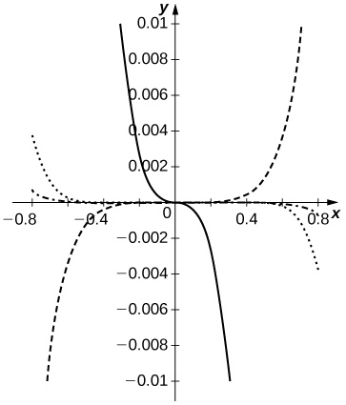

The ratio approximates better than doesfor . The dashed curves are for. The dotted curve corresponds to and the dash-dotted curve corresponds to. The solid curve is .

235. If, find the power series expansions of and

Answer: By the term-by-term differentiation theorem,  so, whereas so .

237 **[T]** Suppose that a set of standardized test scores is normally distributed with mean and standard deviation. Set up an integral that represents the probability that a test score will be between  and and use the integral of the degree  Maclaurin polynomial of to estimate this probability.

Answer: The probability is where and, that is, 

239. **[T]** Suppose thatconverges to a function such that,and . Find a formula for and plot the partial sumfor on

Answer:

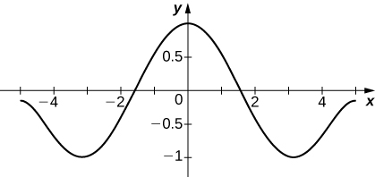

As in the previous problem one obtains  if  is odd andif  is even, so leads to.

241. Suppose that converges to a function such that  whereand . Find a formula that relates, and and compute.

Answer:  and soimplies that  or  for all.andso,, , and.

**The error in approximating the integralby that of a Taylor approximation is at most . In the following exercises, the Taylor remainder estimate** **guarantees that the integral of the Taylor polynomial of the given order approximates the integral of with an error less than**

1. **Evaluate the integral of the appropriate Taylor polynomial and verify that it approximates the CAS value with an error less than**
2. **Compare the accuracy of the polynomial integral estimate with the remainder estimate.**

243. **[T]**;  (You may assume that the absolute value of the ninth derivative of  is bounded by.)

Answer: a. (Proof) b. We have. We have whereas so the actual error is approximately.

**The following exercises deal with Fresnel integrals.**

245. The Fresnel integrals are defined byand Compute the power series of and and plot the sums and of the first nonzero terms on

Answer:

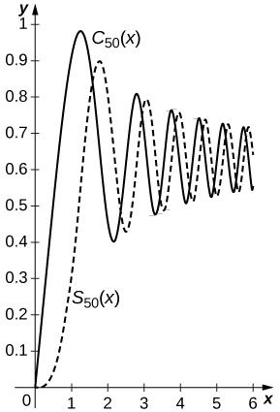

Since and, one has  and. The sums of the first  nonzero terms are plotted below with the solid curve and  the dashed curve.

247. Estimate by approximating using the binomial approximation

Answer: 



whereas .

249. Use the approximation to approximate the period of a pendulum having length  meters and maximum angle where. Compare this with the small angle estimate

Answer:  seconds. The small angle estimate is . The relative error is around  percent.

251. Evaluate in the approximation to obtain an improved estimate for .

Answer: . Hence.

**Chapter Review Exercises**

***True or False.* In the following exercises, justify your answer with a proof or a counterexample.**

253. If the radius of convergence for a power seriesis , then the radius of convergence for the series is also .

Answer: True

255. For small values of ,

Answer: True

**In the following exercises, find the radius of convergence and the interval of convergence for the given series.**

257. 

Answer: ROC: ; IOC:

259. 

Answer: ROC: ; IOC:

**In the following exercises, find the power series representation for the given function. Determine the radius of convergence and the interval of convergence for that series.**

261. 

Answer: ; ROC: ; IOC:

**In the following exercises, find the power series for the given function using term-by-term differentiation or integration.**

263. 

Answer: integration:

**In the following exercises, evaluate the Taylor series expansion of degree four for the given function at the specified point. What is the error in the approximation?**

265. ,

Answer: ; exact

**In the following exercises, find the Maclaurin series for the given function.**

267. 

Answer: 

**In the following exercises, find the Taylor series at the given value.**

269. , 

Answer: 

**In the following exercises, find the Maclaurin series for the given function.**

271. 

Answer: 

**In the following exercises, find the Maclaurin series for by integrating the Maclaurin series of term by term.**

273. 

Answer: 

275. Use power series to prove Euler’s formula: 

Answer: Answers may vary.

**The following exercises consider problems of annuity payments.**

277. A lottery winner has an annuity that has a present value of million. What interest rate would they need to live on perpetual annual payments of?

Answer: 

This file is copyright 2016, Rice University. All Rights Reserved.